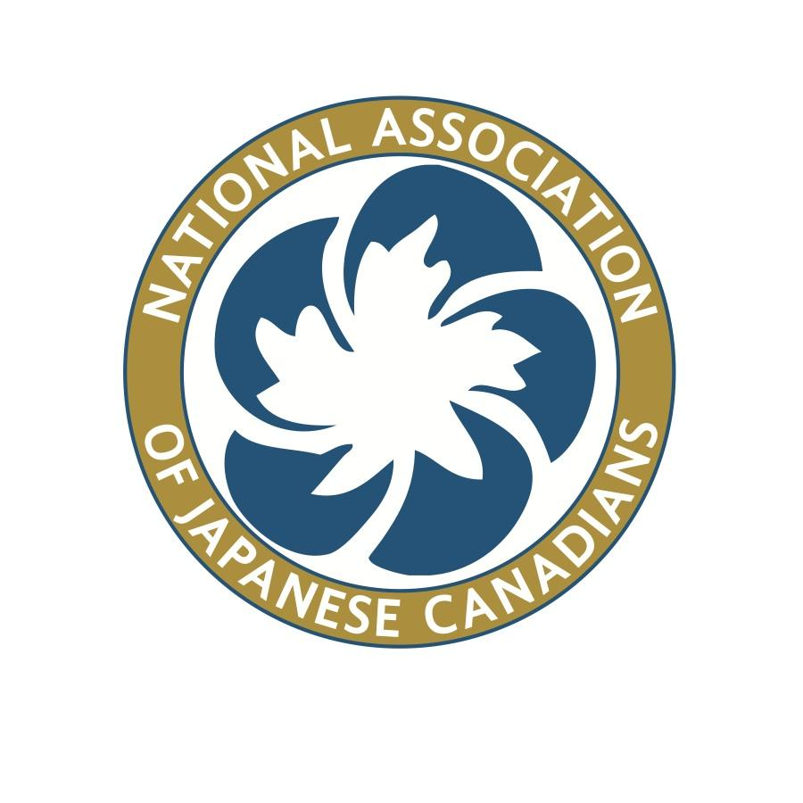

National Association of Japanese Canadians
National Executive Board
ZOOM MEETING
TUESDAY, FEBRUARY 14, 2017
(All meetings: 8pm EST; 7pm CST; 6pm MST; 5pm PST)

MINUTES

- Present:

David Mitsui, President
Lorene Oikawa, Vice President
Noreen Kuroyama, Treasurer
Bev Ohashi, Past President
Eiko Eby, Director
Susan Matsumoto, Director
Bryan Tomlinson, Director
Lisa Uyeda, Director

Ken Noma, Executive Director
Terumi Kuwada, Interim National Administrator

Regrets:
Michiko Yano Shutttleworth, Secretary,
Susanne Tabata, Director

- Minutes Recorder: Ken/Terumi

- Approval of the Agenda:
Dave added an item to the Agenda: response to Ren Ito’s letter
which will be discussed “in camera”
Moved by Eiko, seconded by Lorene, Carried

- Approval of Minutes: NEB meeting: Jan 14-15, 2017 (Toronto) Dave
Moved to approve with noted changes
Moved by Lisa, seconded by Bryan, Carried

- President’s Report Dave
initiating review of ED, with input by NEB members

- Treasurer’s Report Noreen

  - Financial statements sent out a few weeks ago - summary of year, which is similar to last year. Investments have dropped due to market fluctuations and spending. Auditors check for any expenditures outside the mandate of the organization. No concerns have been expressed. Will then be presented to the National Council.

Kevin had some questions on the original draft but were resolved after discussions with Les.

Bev raised a point about very few changes from the financials of March 2016 and the current document, thus questioning the reasons for such a prolonged time span to complete a final draft of the Audit. No information was available.

Motion: The NEB accept and approve the audited financial statements ending March 31 End of Fiscal Year 2015/16.
Moved Noreen, seconded Lorene Carried

b. Budget 2017/18 - dealt with under later agenda item.

- Hiring an accountant - 8 hours per week (per Kevin Okabe’s suggestion),
$250/month, would be $3000/year. Discussed various factors related to contracting for accounting services, including the NA’s skill level in bookkeeping.

Motion: NEB to allow for up to $5000 go towards hiring an accountant with QuickBooks.
Moved Noreen, seconded Lorene Carried

- Market value of investments is currently at $4,597,000

G. Past-President’s Report Bev

Suzuka Scholarship - in touch with contacts at Suzuka regarding support of just one candidate due to budgetary constraints. Second candidate would be subject to external sponsorship. Will keep it at one candidate for now. Anne Shaw offered to sit on the YLC.

ACTION: Bryan to reach out to Anne regarding candidacy on the Young Leaders Committee.

H. Executive Director’s Report Ken
a. Gordon Hirabayashi Award vs. Art Miki Leadership Award. Looking to strike a committee to review nominees. Unfortunately only one candidate last year. P&P Manual has background info on all awards (including conditions, etc.) - Ken seeking direction from the NEB on how to designate an award winner. ACE Committee also has a new award, but not clear what their process is. Suggesting that ACE Committee look at the awards this year, with finalists subject to NEB approval.

Note: Art Miki Award recipent travel costs (if out of province) is not currently covered under the AGM budget. Traditionally recipients are in the cities where AGMs are held, but may not always be the case.

ACTION: NEB members to think about how to address this process on the Art Miki Leadership award before the end of March in order to slot this into the AGM programming.

b. One Pager on Annual Deadlines - to member organizations. Important to note are calls for nominations for the Endowment Fund, applications for Community Development Fund. Standing committees have some suggested deadlines - short timeline in particular on the FY2018/19 Budget, in anticipation of Calgary meeting in May. Need to forecast and discuss with our respective committees. Need to get a handle on the FY18/19 in good form for the 2017 Ottawa AGM.

ACTION: NEB Directors to examine outline of FY18/19.

c. Terms of Reference will be created for the Executive Director, based in part, by Henry Kojima’s original proposal for a full time Executive Director.

d. Revised 2017 Ottawa AGM Budget - Karen Shigeshi-Waite submitted an updated budget. Bulk of $30,000 is going towards transportation/accommodation costs. Very little left over for the conference itself (venue is free, but services and catering not). Venue and hotels are confirmed. Suggesting to increase to $40,000 (commensurate with Calgary); may have potential surplus of $2000, which could be redirected for a commemorative booklet. Linda Reid at Nikkei Museum is thinking about putting together a commemorative booklet. Ken will correct the number of NEB members attending (from 9 to 12).

MOVED: to increase the 2017 Ottawa AGM Budget from $30,000 to $40,000
Moved Bryan, seconded Lisa U. Carried

I. National Administrator’s Report Terumi

Financials - Kevin Okabe on Feb 1 met with Terumi to discuss finances and accounting. One option that was discussed between Kevin and Terumi was to approach a former NA who has a strong accounting background to an 8 hour/month accounting contract. She will advise Terumi of her status shortly. Discussed overpayments to some registrants to JCYLC where there was possibly some miscommunications. Kevin continues to finalize the financials of the AGM in Calgary and make recommendations. Need to learn from this situation so there is clear understandings of subsidies and other financial issues.

NA Posting – the office has received some applications, inquiries, etc. Two inquiries have come from Toronto, as the ad did not indicate location of the position. There is interest in Winnipeg from various individuals. Terumi will be following up with individuals who have requested more information.
Office computer - some of the computer tasks have been a bit challenging, but have had a “tekkie” come in to help service the computer.

J. Strategic and Financial Planning All

i. 2017-18 Budget: Committee Chairs
Confirmation of Priority Action Steps and Budget allotments

Motion for the NEB to approve the FY2017/18 Budget in principle.
Moved Noreen, seconded Eiko. Carried

ii. 2018-19 Draft Budget – 1st draft to be developed in May 2017

Per Ken Noma’s comments earlier under H(b.), NEB Directors are asked to discuss next year’s budget with their committees.

iii. Strategic Plan & Tactical Plan

Bryan commented on some of the changes that he will be proposing for the YLC and will submit to Bev

ACTION: NEB Members asked to submit updates to the document by Friday February 17.

iv. Future Directions Committee
Bev commented on some changes that will be made in the area of Education and New Immigrants

K. Business Arising from NEB Meetings/Minutes
i. Charitable Status – Hastings Park Foundation Ken
(Covered under ED report)

ii. Canadian Race Relations Foundation - follow-up Lorene
No update

iii. Bilingual Human Rights Guide for Japanese Canadians Lorene

iv. NAJC National Administrator Search Ken/Terumi
(Covered under NA report)

v. National Office Storage and Archival Assessment Project Lisa
No updates

vi. 2016 AGM Summary of NAJC Member Organizations’
Queries Bev/Dave
NEB to send in electronic comments to Bev.

vii. NAJC Email address Hacks inquiry Ken
(Covered under ED report)

L. NEB Standing Committee Follow-ups & Reports
i. Human Rights Committee Lorene
- Mayoral counter-measure for removal of racist politician’s name, regarding the MacNeill School in Port Alberni. Letter to the editor was published. Lorene spoke to City Councillor and School Trustee to support removal of racist politician’s name, regarding the MacNeill School in Port Alberni.
- NAJC HR statements are reported in the media, some reader’s comments are hateful and discriminatory.
- 22 March (TBC) Webinar “Meet and greet” of JCs engaged in Human Rights across Canada, starting via provincial themes. This will help build a human rights network.
ii. Membership Committee Eiko
- order swag (in two orders - some to Michiko). Tracey Suzuki had charged some expenses to her credit card. Eiko to have her send Terumi the invoice.
Moved that Naomi Katsumi join the Membership Committee for work on promotions and the brochure.
Moved Eiko , seconded Lorene Carried

iii. Arts, Culture and Education Committee Susanne
- Regrets

iv. Heritage Committee Lisa
- Nominations have been reviewed. Rough calculation of number of hours this has taken since Oct 2016, totalling 45-50 hours.

v. Community Development Committee Michiko
- Regrets, and no report sent.
- Cosplay is on NAJC site and on twitter account.

vi. Endowment Fund Committee Dave
- no update

vii. Constitution, Resolutions and Bylaws Committee Susan
- quick summary of decision made at the last meeting; the motion will be submitted for the National Committee meeting on 21 Feb.

viii. Nominations Committee Dave
- n/a

ix. JC Young Leaders Committee Bryan
- ED recommendation to delegate tasks - which has been done
- Dave asked to what extent is the youth contingency going to be integrated? Bryan noted that he’s working with the OJCA organizers to ensure that youth are adequately and fully integrated. One ongoing issue is whether youth delegates can afford to attend the banquet.
- Two new members: Alex Miki ( Winnipeg), Nicole Yakushiro (Vancouver)

x. Future Directions Team Dave/Bev
- no updates
- first meeting date: March 20

M. National Council Meetings and Special Projects Reports
i. Community Renewal Fund Dave
- deadline March 31, for applications

ii. Special Committee on Reconciliation Lorene
- see ED report

iii. Social Media Project Lorene/Ken
- Kayla Isomura has developed Facebook site. Lorene already did a soft launch of Twitter.
- Broad guideline being put together on this.
- Invite all NEB members to use social media.
- Bryan invited for Alex Murata to help out with Ken and Lorene as necessary. Bryan can put Hugo Narumiya in contact with Loreen.

iv. ZOOM meeting: Feb 21, 2017 - Agenda Dave
- Audited Fiscal Statement for FY15/16
- Ken to send out agenda to NEB
- Film festival (???)

N. New Business
i. Honourarium for Kevin Okabe Dave
- Further to discussion in January NEB meeting, possibility of an honorarium to thank him for his contributions to date.
- Dave suggest to table this for now, given ongoing work.

ii. Contract Accountant Dave
- see discussion under Budget

iii. Lifetime Achievement Award Suggestion Dave
Motion to table for next meeting
Moved Lorene

The NEB Board went “ in camera” at this time: 21:56 EST
The NEB Board came out of “camera” at this time: 22:37 EST

O. Annual AGM’s and Conferences
i. 2017 Ottawa AGM and Conference Update (Sept 22-24) Ken
ii. 2018 Winnipeg AGM and Conference (Sept 21-23) No updates

P. Adjournment

Move to Adjourn Lorene, Seconded Noreen Carried
Adjourned 22:38

