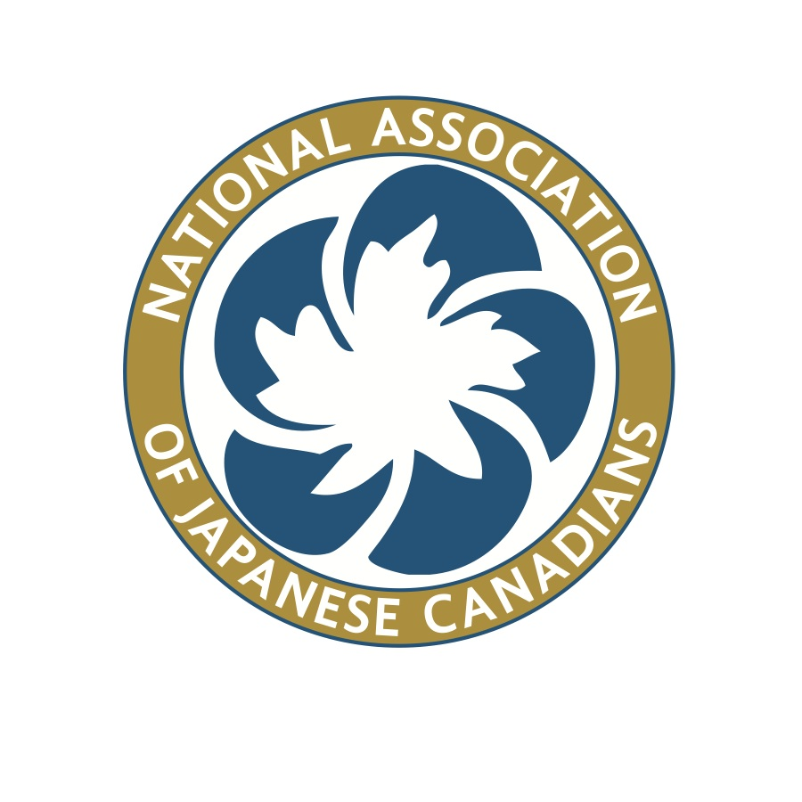
National Association of Japanese Canadians
National Executive Board
ZOOM MEETING MINUTES
Thursday, December 15, 2016
(All meetings: 8pm EST; 7pm CST; 6pm MST; 5pm PST)
Start Time: 8:40 pm EST

- Roll Call:
David Mitsui, President Lorene Oikawa, Vice President
Noreen Kuroyama, Treasurer Michiko Yano Shutttleworth, Secretary
Bev Ohashi, Past President Susanne Tabata, Director
Eiko Eby, Director Lisa Uyeda, Director
Susan Matsumoto Terumi Kuwada, Interim NA
Ken Noma – Executive Director

- Minutes Recorder: Ken Noma

- Moved by Lorene Oikawa, seconded by Bev Ohashi to approve the agenda as amended.
-Carried

- Moved by Lisa Uyeda, seconded by Eiko Eby to approve the October 15-16, 2016 minutes -Carried
- Business Arising from NEB Meetings/Minutes

i. 2016-17 Budget Dave/Ken
Chairs confirmed the 2016-2017 budget re-allocations from October NEB meeting

Moved by Eiko Eby, seconded by Bev Ohashi to hire William Archibald to
create a master list of the 22,000 Japanese Canadians incarcerated by the Canadian Government during World War II. An amount of up to $2,000 will be allocated towards this project. –Carried

It was recommended that Mr. Archibald first examine the list of available names that has been compiled by the Nikkei National Museum, Burnaby prior to determining whether a visit to the Library and Archives Canada is warranted. This project will come under the ED and Special Projects
Advisor.

Moved by Susan Matsumoto, seconded by Lorene Oikawa to approve the
Appointment of Terumi Kuwada to oversee the transition/training process
after December 5, 2016 until such time a replacement National Administrator
is hired and her services are no longer required. – Carried
Moved by Michiko Yano-Shuttleworth, seconded by Susan Matsumoto to
Accept the Terms of Service for the Advisor for Special Projects as amended.
- Carried

Moved by Lorene Oikawa, seconded by Eiko Eby to appoint Tosh Kitagawa
As Advisor for Special Projects. – Carried

Moved by Lisa Uyeda, seconded by Susanne Tabata that Bryan Tomlinson
Be appointed as the Chair of the Young Leaders Committee
- Carried with one objection by Bev Ohashi

It was noted that the YL Committee must bring forward specific projects
beyond conferences and identify clear objectives and strategies for the engagement of a larger community of youth prior to NEB budget approval.

ii. 2016-17 Strategic Plan Bev
No discussions at this time

iii. 2017-18 Strategic Plan Dave/Bev
Further discussions will take place at the January NEB meeting

iv. 2017-18 Budget Dave/Ken

Committee chairs were requested by the President to look at areas for cutbacks and potential revenue generation.

v. Future Directions Team Bev
Report in the Past President’s Report

vi. Suzuka Scholarship Bev
Report in the Past President’s Report

vii. Conflict of Interest Forms Ken
Forms have been distributed via email and will be collected at the January
meeting

viii. NEB Biographies and Photos on Website Ken/Lisa
Lisa has provided a sample template to the NEB members

ix. Charitable Status – Hastings Park Foundation Ken
No report at this time

x. CRRF follow-up Lorene
No report at this time

xiii. Funds approved to speak at Warrior Spirit Exhibit Dave
Completed.

xiv. Dr. John Price: 75 Years is Long Enough Ken/Lorene
NEB approved support (via email) and eNews sent out.
Strategy moving forward to be determined

xv. Japanese Canadian War Memorial Report Linda Kawamoto Reid
Report submitted to NEB

- President’s Report
Report submitted to NEB
Dave
National Administrator, Jim Suzuki’s, Resignation noted
NEB informed that the Executive Director’s 3 year contract ends Oct 2017 and
that he will be conducting the review followed by recommendation for action
Acknowledged Noreen’s work on the Quickbooks transition from Excel.

- Treasurer’s Report Noreen
Report was submitted to the NEB. Noreen acknowledged Kevin’s help in
helping with the financial report for January 2017.

- Executive Director’s Report Ken
Report filed with the NEB with action items for followup.

- Interim National Administrator’s Report Terumi
-Submitted to NEB

- Past-President’s Report Bev
Submitted to the NEB

- NEB Standing Committee Follow-ups & Reports (maximum of 2 minutes per report)

i. Human Rights Committee Lorene
Report submitted to NEB

Moved by Lorene Oikawa, seconded by Susanne Tabata to approve the
Social Media Agreement Contract. –Carried

Moved by Lorene Oikawa, seconded by Susanne Tabata to appoint Kayla
Isomura as the Social Media service provider. - Carried

Bilingual Human Rights Guide for Japanese Canadians was deferred
to January

ii. Membership Committee Eiko
Report submitted to NEB

Tracey Suzuki will be ordering NAJC swag bag items
Recommendations made on the membership form and to separate
individual membership from the member organization application form. In
addition, an agreement form (rather than a signature) be added. Questions
were raised around incentives and age categories necessitating a more
detailed discussion in January.

iii. Arts, Culture and Education Committee Susanne
Report submitted to the NEB.
Update on the JC Directory given with breakdown on the monetary and
In-kind contributions by the partnership.
Attempt will be made to acknowledge older generation of JC artists omitted
From the Suzuki directory.
Action 1: Terumi to report back on the revenue raised by the sale of the
tee shirts.

iv. Heritage Committee Lisa
A full report will be made in January

v. Community Development Committee Michiko
Toronto Chapter will be making a donation to the Momiji Senior Centre
towards their purchase of a van.

Work on the Cosplay workshop in Toronto continues

vi. Endowment Fund Committee Dave
Moved by Lorene Oikawa, seconded by Michiko Yano-Shuttleworth
to approve Kayla Isomura and Andre Boutin-Maloney to sit on the
Endowment Committee for a term of two years.

vii. Constitution, Resolutions and Bylaws Committee Susan
Several areas of potential bylaw change has been identified and will be
Discussed further by the Committee.

Action 2: Need to clarify whether the bylaw changes passed by
the National Council has been submitted to Corporations Canada.

viii. Nominations Committee Dave
None

ix. National Honourary Advisory Committee Bev Report in the Past President’s Report

L. National Council Meetings and Reports
i. Community Renewal Fund Dave
Report submitted by Art Miki

To date approvals given to JCAM, Kamloops, Vernon and the Nikkei
National Museum.
The Committee has forwarded recommendations for NEB discussion

M. New Business
i. Ambassador of Japan Conference Dave
The President and Lorene Oikawa have been invited to attend the Jan 12 and 13, 2017 meeting being held in Montreal.

N. Annual AGM’s and Conferences
i. 2016 Calgary AGM and Conference Update (Sept 9-11) Ken
Receipts are still being collected and will be forwarded to Kevin.

ii. 2017 Ottawa AGM and Conference Update (Sept 22-24) Ken
A video conference was held with the ED and the Ottawa organizing
Committee on December 13th with discussions around workshops and
budget.

The President has sent a formal letter to Prime Minister Justin Trudeau inviting him to the Saturday night banquet and to deliver the keynote address.

O. Adjournment at 10:08 pm EST

UPCOMING MEETINGS:

NEXT MEETING: JANUARY 13, 14, 2017 TORONTO

NEB Meetings i. ZOOM Video Conference
-Tues Nov 8, 2016 (cancelled)
-Tues Dec 13, 2016 (moved to Dec 15, 2016)
-Tues Feb 14, 2017
-Tues Mar 14, 2017
-Tues Apr 11, 2017
(All meetings: 8pm EST; 7pm CST; 6pm MST; 5pm PST)

ii. FACE TO FACE MEETINGS
-Toronto -January 13-15, 2017
-Location (Calgary?) -May 26-28, 2017
-Ottawa /Gatineau -September 22-24, 2017 (AGM and Conference)

NATIONAL COUNCIL ZOOM Video Conference meetings with NEB:
-Tue Mar 21, 2017
-Tue May 30, 2017
(All meetings: 8pm EST; 7pm CST; 6pm MST; 5pm PST)

(NAJC-NEB-1Agenda-Dec2016)

